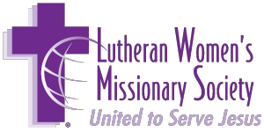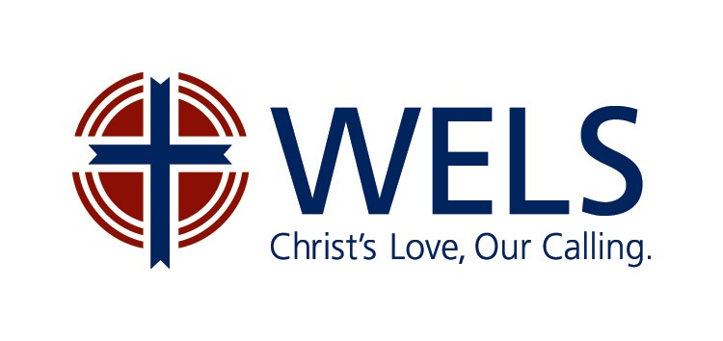
LWMS GRAND CANYON CIRCUITS WEEKEND RETREAT
Camp Shadow Pines, Heber, Arizona
October 7 – 9, 2022

SPREAD THE WORD

“Their Voice goes out into all the Earth, their Words to the Ends of the World.” PSALM 19:4

Guest Speakers:
Ms. Emily Kom, LWMS Past President.
She will address the topics of “Revitalizing Reporters” and “Missionary Journeys”.
Ms. Kay Retberg, Missionary Wife
She will share her experiences about returning home from a world mission field.

Saturday Evening:
Mr. Steven Bautista, a Christian entertainer and musician.

Sunday Morning:
Worship service with Communion.

Board Recommendation for Mission Fund (75%): #WM-2022-05: New World Mission Fields
Your gifts will allow for thorough follow-up research as well as multiple exploratory trips to each new location (Bangladesh, London, Senegal, Latin America and Thailand)
Board Recommendation for Freewill Offering: #WM-2022-03: Repatriation Conferences
This will help to support our missionaries and their families as they transition back to life in the USA.

NOTE: Road construction on Hwy 260, Camp is at mile marker 300.
For Camp information, Google: Camp Shadow Pines Heber Arizona.

Please Register with mail-in form or online by September 17th.
www.gcwlwms.org

